Python Script Install

1. Download Python 3.7 installer and open the .exe file.
   1. <https://www.python.org/downloads/>

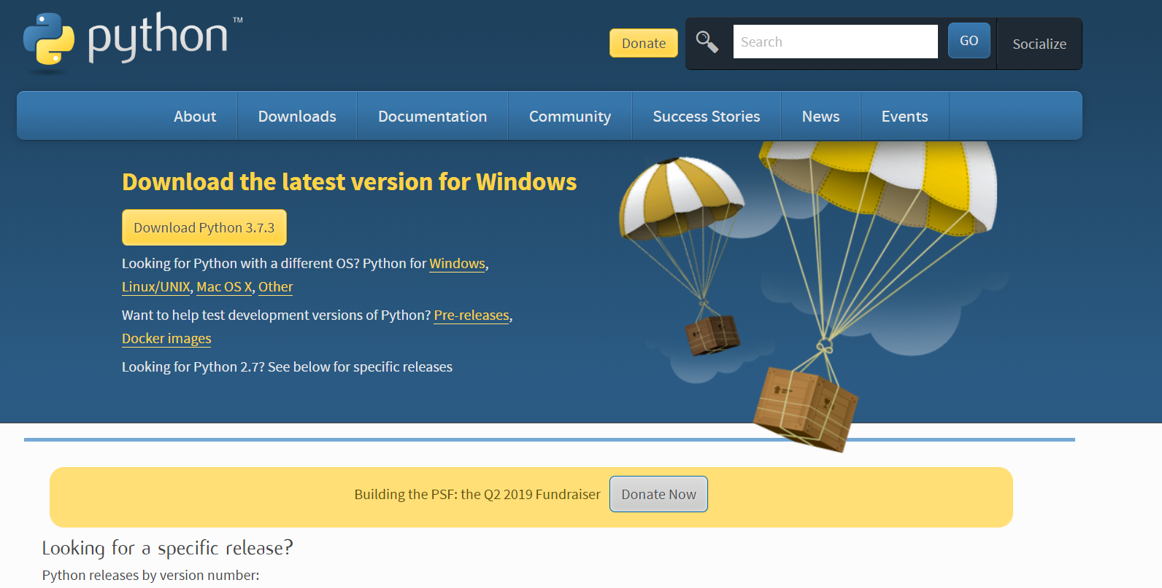

1. During installation, make sure to click the box labelled “Add Python 3.7 to PATH”

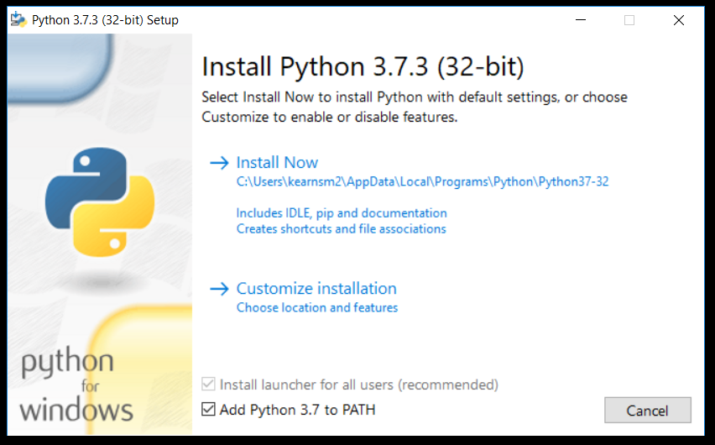

1. Click the “Install Now” option. If prompted to disable the path limit, disable it.
2. After that is installed, open the command prompt by typing “cmd” in the windows search bar on the bottom left of your screen.
3. In the command prompt, type “python”.
   1. This will check to see if python is installed properly. The response should look like the image below.

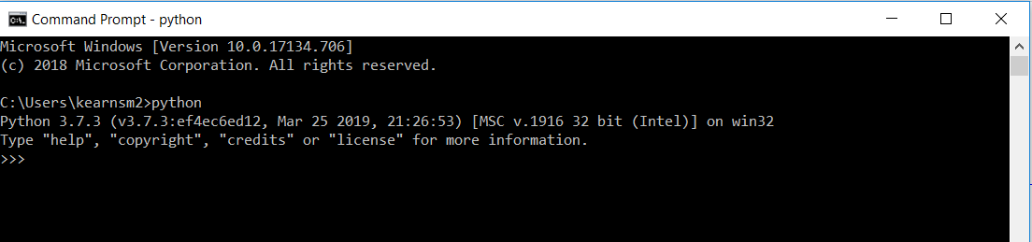

1. Close the command prompt and then open it again.
2. Use “pip” to install the Smartsheet Software Development Kit (SDK)
   1. In command prompt type “pip install smartsheet-python-sdk” and hit enter to install
   2. After that is installed, type “pip install pysimplegui” and hit enter.
   3. These commands will output information on the download and install of the package.
   4. See Below for examples of what the inputs and outputs of the Command Prompt should look like.

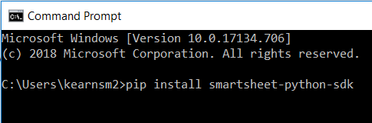

Pip install using Command Prompt

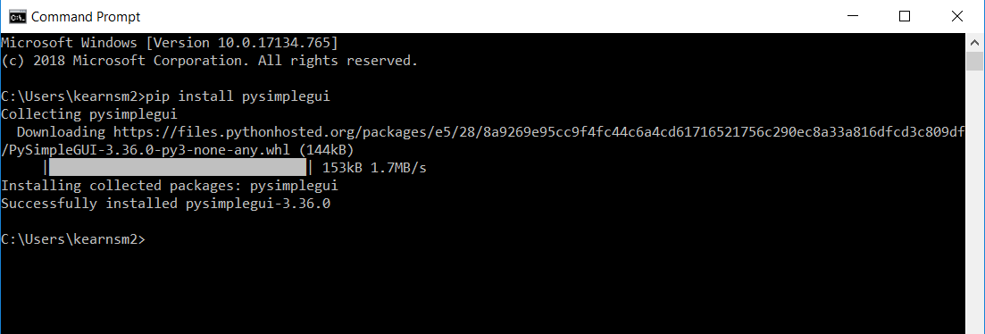

Pip install of PySimpleGUI. The only user input is “pip install pysimplegui”, everything else is printed by the Command Prompt

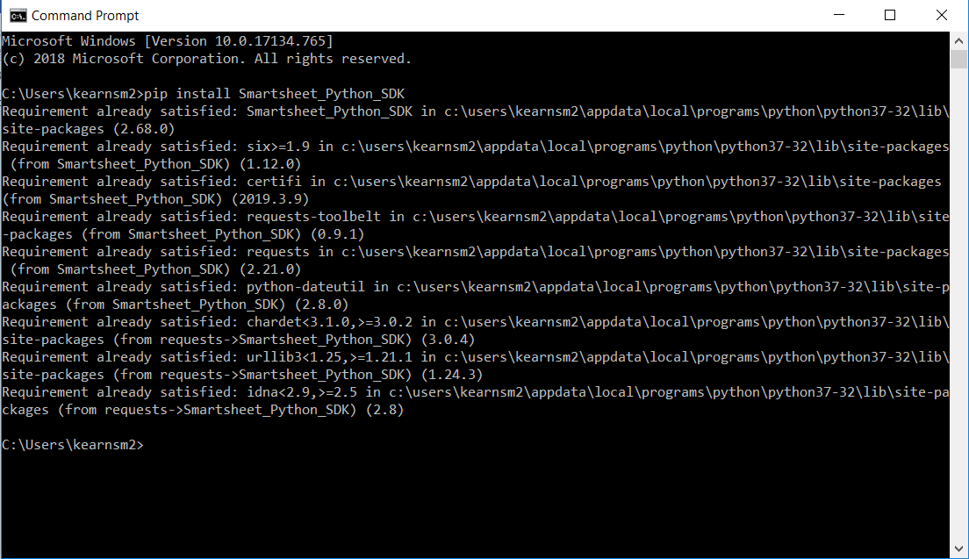

Example of what happens when you already have a package installed. The only thing the user typed here was “pip install Smartsheet-Python-SDK”, everything else is printed by the Command Prompt.

1. Download python script from box.com
   1. <https://nengvdc.app.box.com/folder/76419101937>
2. Double click python script to run, a windowed prompt should appear.

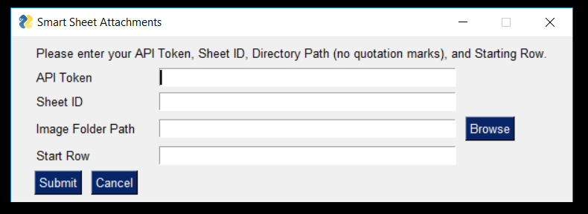

1. Enter smartsheet information.
   1. How to find that information is explained on the next page.

Smartsheet Information

API Token: Unique to each person, identifies user when utilizing API. (See below to check how to get your API Token)

Sheet ID: Identifies a sheet. Can be found under File >> Properties

Image Folder Path: Location of folder containing all images to be uploaded. In the python window, select browse and navigate to the folder containing your files to upload.

How to get your API Token:

* Go to smartsheets, click on your profile on the top right corner, and navigate to Personal Settings.
* Click on “API Access” and then “Generate new access token”
* Give the token a name, and then copy the token and paste it somewhere that is easily accessible. If your lose your API Token at any time, you can always create another token.

